Client and Appointment Project -

- CRC Cards:
User
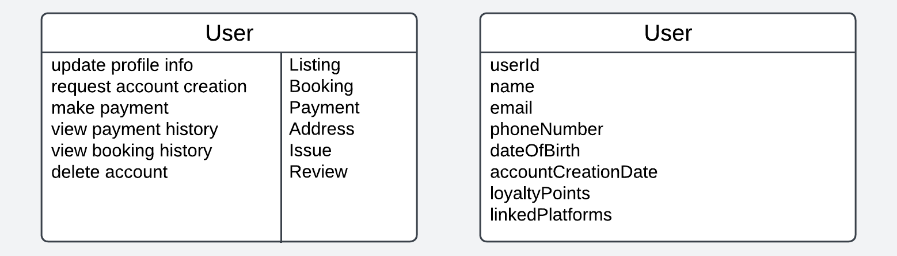

Address
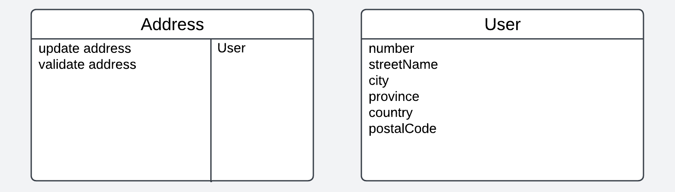

Payment
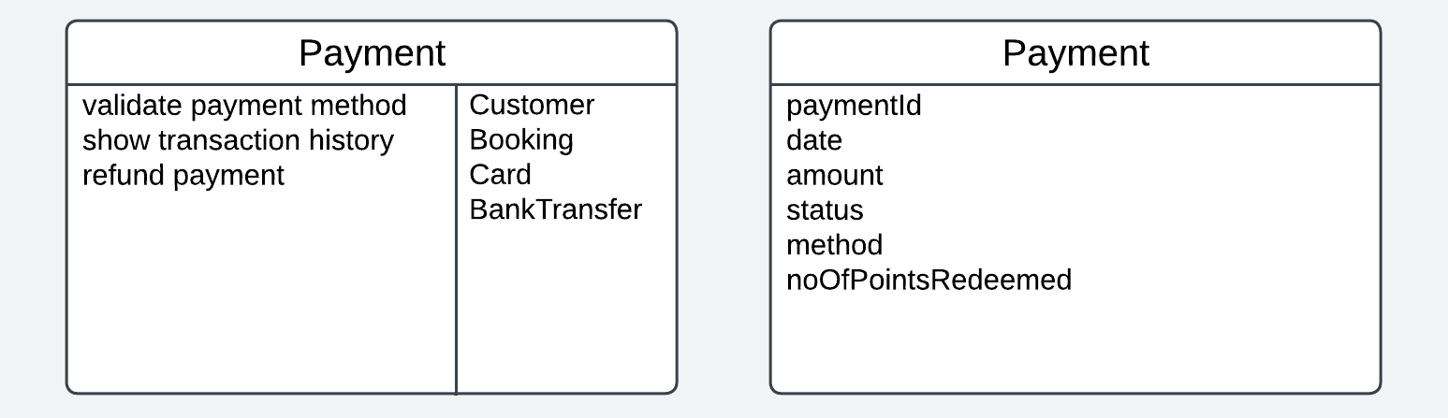

Booking
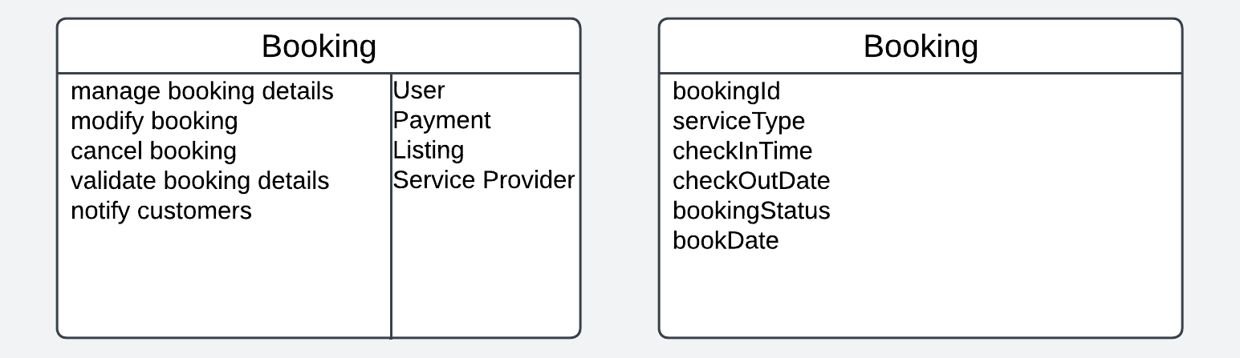

Listing
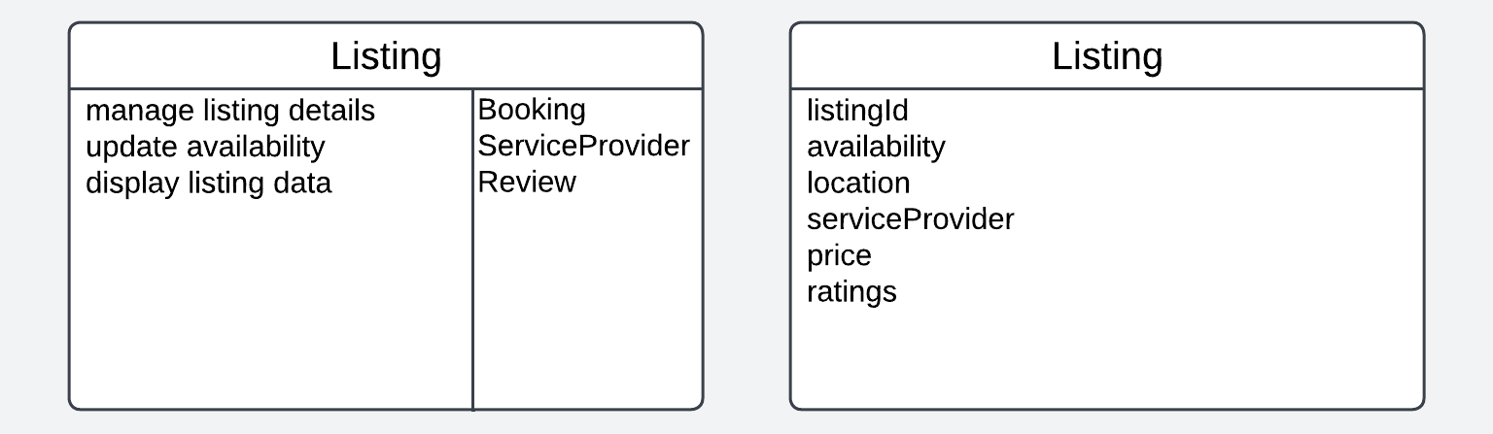

Service Provider
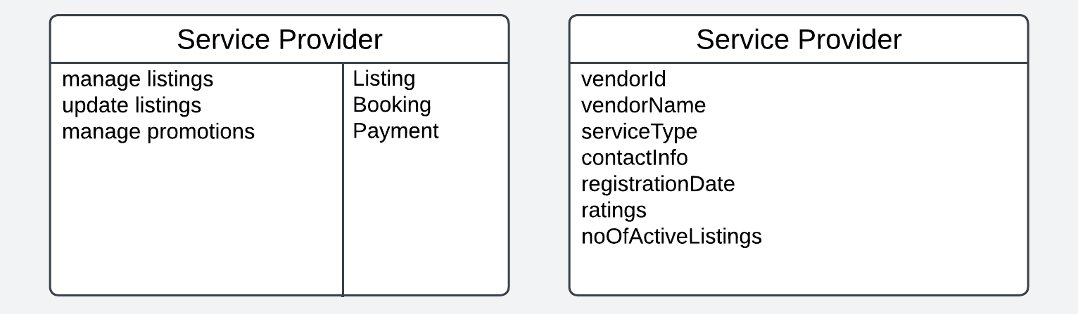

Customer Service Representative
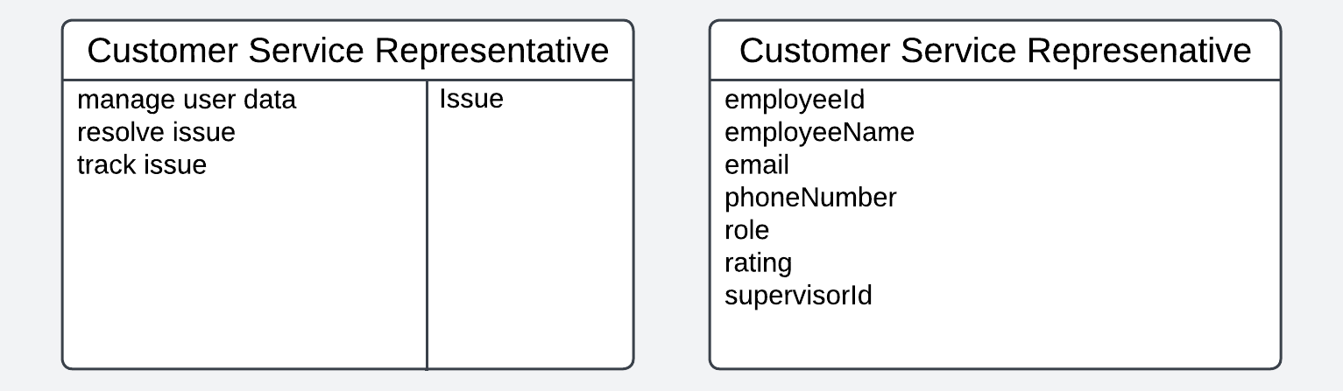

- Communication Diagrams:

Create User Account Use Case 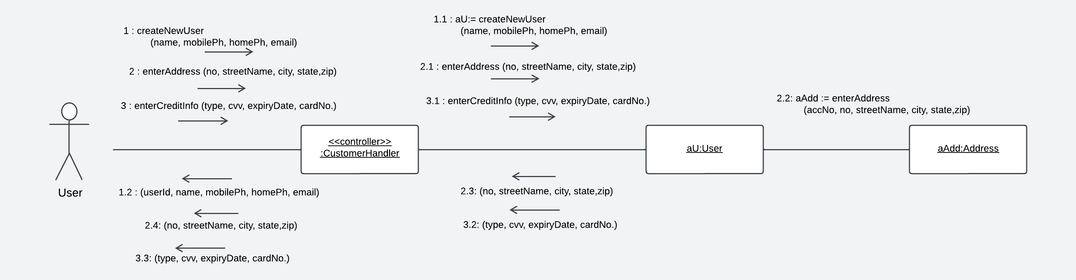

View Past Bookings Use Case
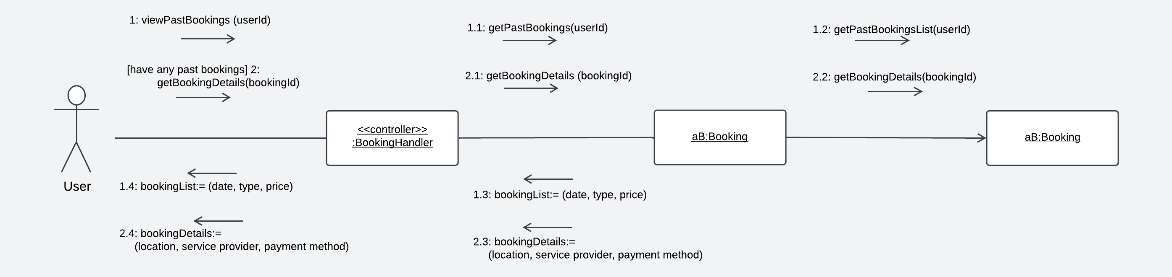

Sequence Diagram:
Make Payment Use Case
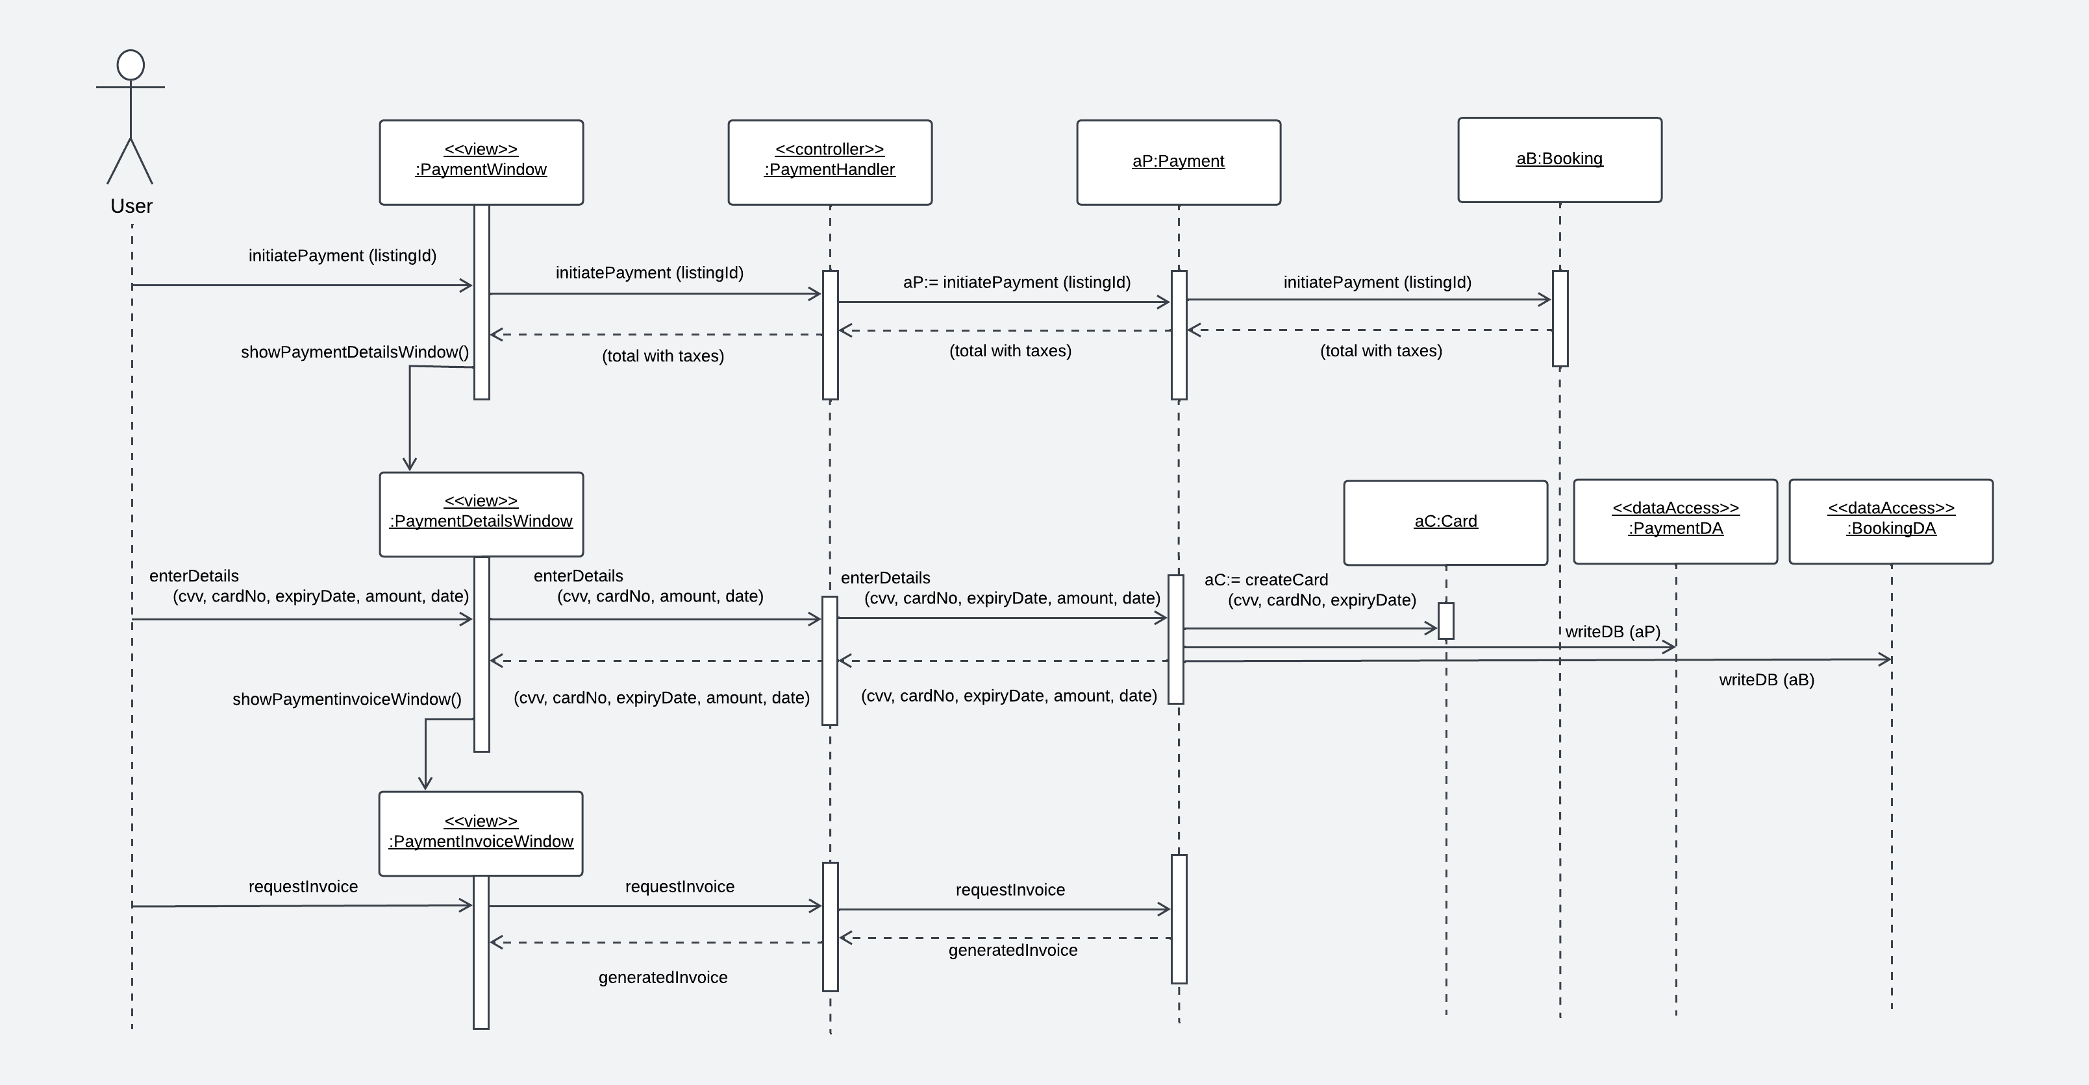

Book Service Use Case:
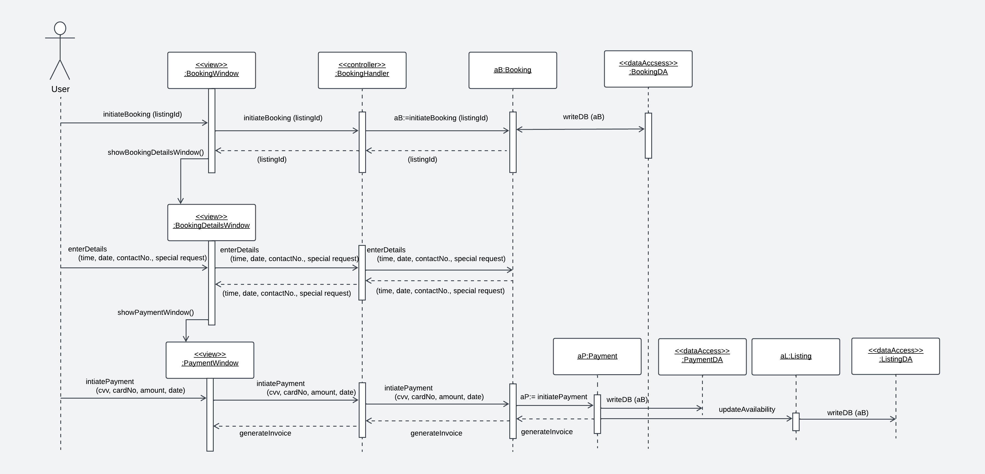

Delete Account Use Case:
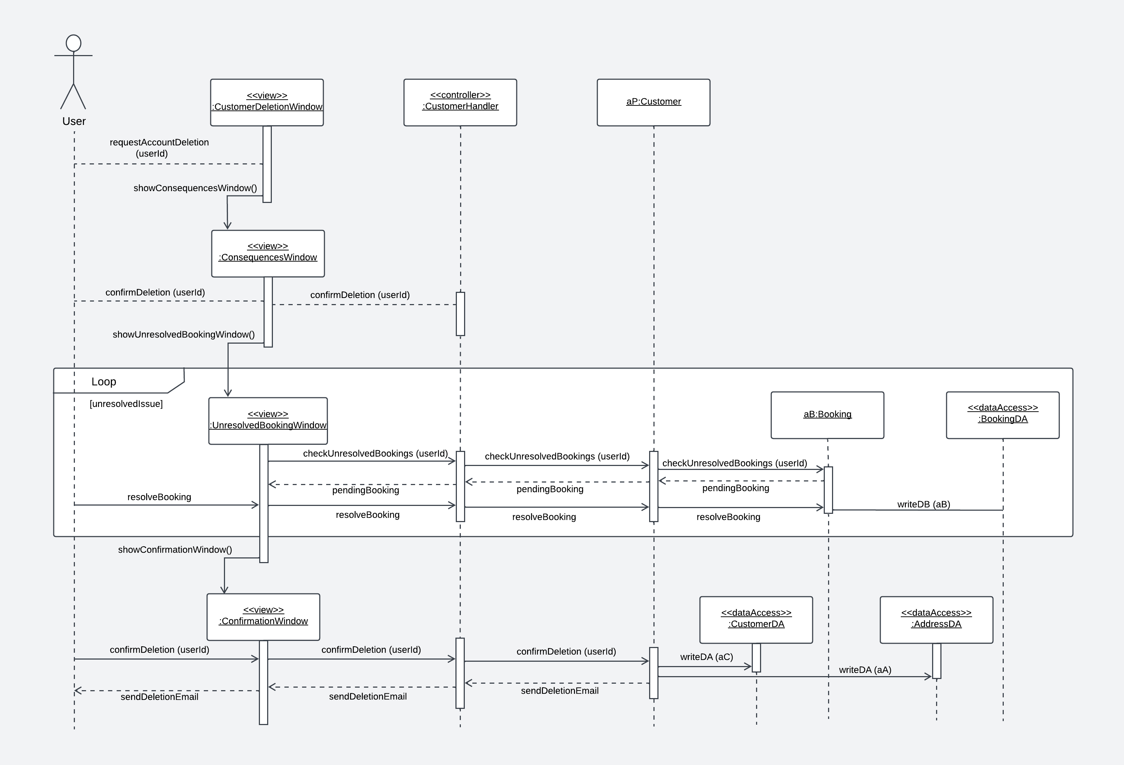

3. Fully Developed Design Class Diagram
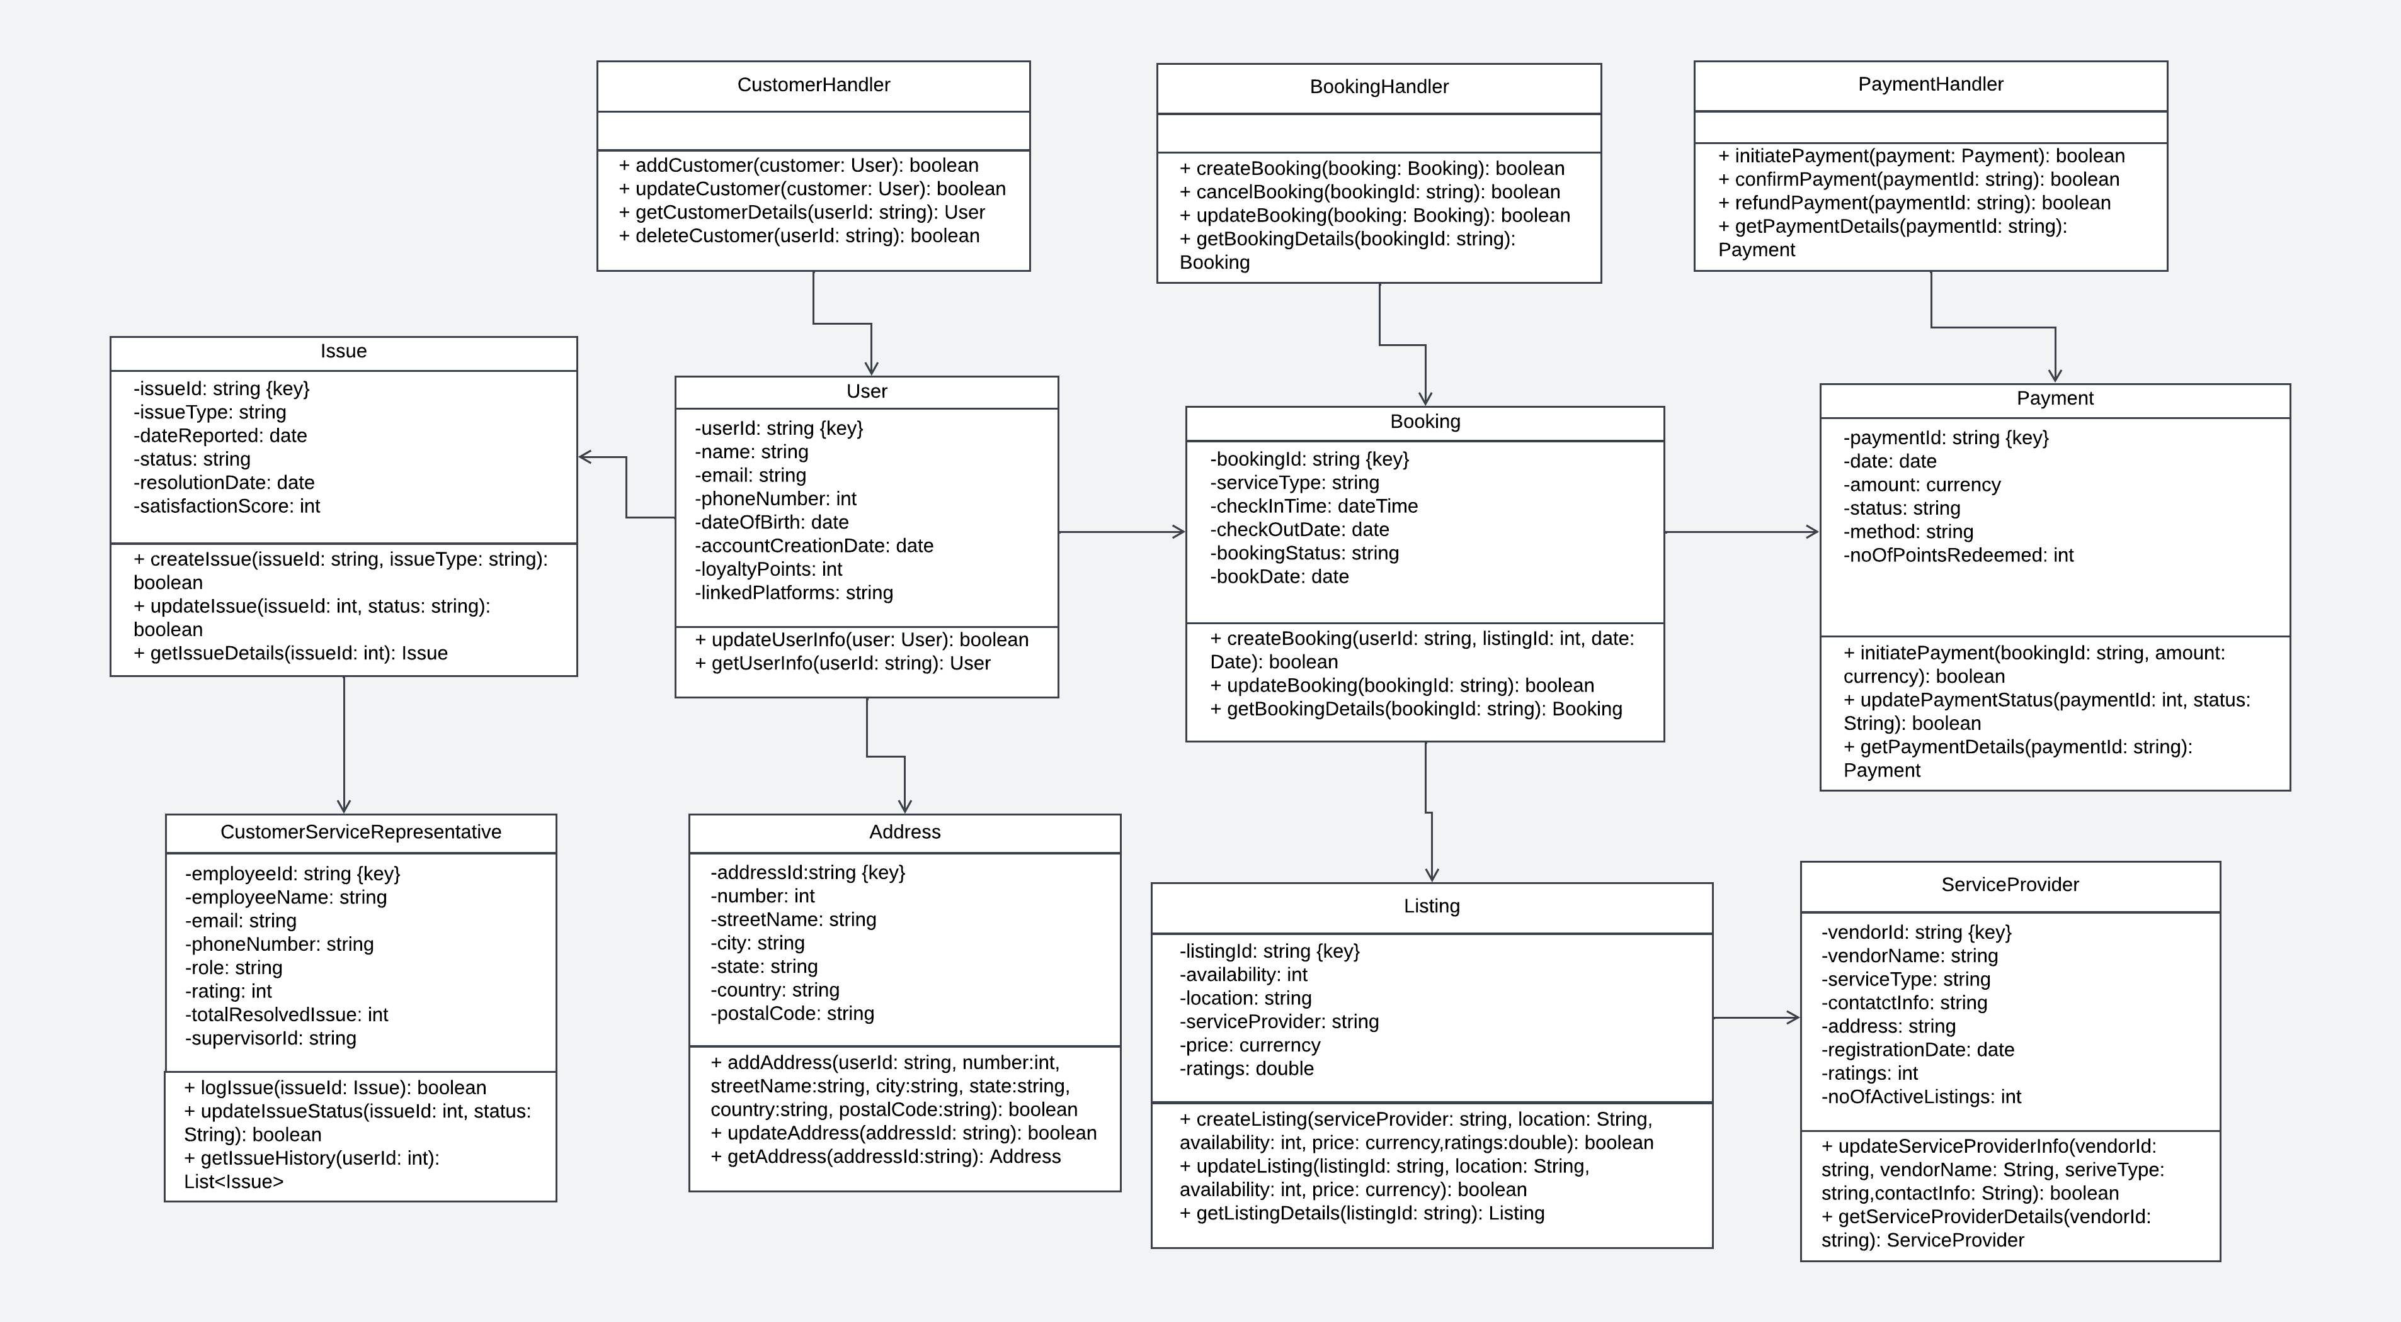
- Class Package Diagram
